**Title: Cost Estimation and Budget Analysis**

**Objective**: The primary goal of this project is to develop a smart, AI-powered software tool that can estimate the total cost of a software development project and analyze the budget distribution across various development phases. By integrating machine learning, the system aims to enhance the accuracy and efficiency of project budgeting, enabling better financial planning and resource allocation.

**1.AI Model Development**

**Overview:**

To design and implement a machine learning model that predicts the estimated cost of software development projects based on key project parameters. The AI model enhances budgeting accuracy and provides valuable insights for project managers and developers.

**Implementation:**

**Supervised Machine Learning:** Supervised Machine Learning in the **Cost Estimation and Budget Analysis for Software Development** project involves training a model using historical data where key project features (team size, duration, complexity, tech stack) are linked to their actual costs. The model learns these relationships and predicts the cost of new projects based on similar inputs. Algorithms like **Linear Regression**, **Random Forest**, or **XGBoost** are used to accurately estimate project costs. This AI-driven approach improves budgeting accuracy, reduces manual errors, and enhances financial planning for software projects.

**Data source:** The dataset for the AI model in the **Cost Estimation and Budget Analysis** project can be sourced from historical data of past software development projects within the organization, if available. If internal data is not accessible, public datasets like those from Kaggle or COCOMO models can be used. Alternatively, simulated data based on industry assumptions or expert knowledge can be generated to train the model. Industry reports and surveys can also be valuable for collecting real-world project cost data.

**Outcome:** The outcome of the AI model development will be an accurate cost prediction tool that estimates the total cost of software projects based on key input features. It will help optimize budgeting, improve financial planning, and provide insights for cost control throughout the project lifecycle.

**2.ChatBot Development:**

**Overview:** The chatbot for the **Cost Estimation and Budget Analysis** project will collect input parameters like team size, duration, and complexity through conversation and use the AI model to provide cost estimates. It will also offer budget suggestions and track cost progress, enhancing user interaction and real-time support for project managers.

**Implementation:**

**1. AI Model Integration –** The chatbot must be connected to the trained machine learning model to process user inputs (like team size, duration, and complexity) and return accurate cost predictions.

**2.Natural Language Processing (NLP) –** To understand and interpret user queries effectively, the chatbot needs an NLP engine (e.g., Rasa or Dialogflow) for intent recognition and input handling.

**Outcome**: The outcome of the **chatbot development** will be an interactive tool that allows users to easily estimate software project costs through a simple conversation. It will provide quick, AI-driven cost predictions, assist in budget planning, and improve user experience by offering real-time support and cost-related insights.

**3.Data Security Implementation:**

**Overview:** In the **Cost Estimation and Budget Analysis** project, data security ensures that sensitive project and budget information is protected through encryption, secure user authentication, and access control. These measures help prevent unauthorized access and maintain the confidentiality and integrity of cost-related data.

**Implementation:**

1.**Data Encryption** – To protect sensitive cost and project data during storage and transmission.

2.**User Authentication** – To ensure only authorized users can access or modify the data.

**Outcome:** The outcome of data security implementation in your project is the **protection of sensitive project and cost data** from unauthorized access, breaches, and tampering. It ensures **data privacy, integrity, and secure access**, building trust for users and stakeholders in using the system.

**4.Testing And Feedback Collection**

**Overview:** Testing in the **Cost Estimation and Budget Analysis** project ensures the accuracy and reliability of the AI model, chatbot, and interface through unit, integration, and user acceptance tests. Feedback from users is then collected to refine the system, improve usability, and enhance the accuracy of cost predictions.

**Implementation:**

1.**Accuracy Validation** – Ensuring the AI model and chatbot provide accurate cost predictions through thorough testing and validation.

**2.User Feedback –** Collecting feedback from actual users to improve system usability, interface design, and functionality based on their experience.

**Outcome:** The outcome of **Testing and Feedback Collection** is a refined system that delivers accurate cost predictions and provides a user-friendly interface. Continuous improvements are made based on feedback to enhance usability and system performance, ensuring a better user experience.

**Challenges and Solution:**

**1.Challenge: Inaccurate Cost Predictions**  
**Solution:** Continuously improve the AI model by training it with high-quality, diverse datasets and regularly validating the model’s performance to ensure more accurate and reliable predictions.

**2.Challenge: Data Security**  
**Solution:** Implement strong data encryption, secure authentication, and access control mechanisms to protect sensitive project and cost data from unauthorized access or breaches

**Outcomes of Phase 3:**

1. **Accurate Cost Predictions:** The AI model will accurately estimate software project costs based on various parameters, improving budget planning and financial forecasting.
2. **User-Friendly Chatbot:** A functional chatbot will assist users in gathering cost estimates, providing budget suggestions, and improving user experience with real-time support.
3. **Data Security:** Ensured protection of sensitive project and financial data through robust encryption, secure authentication, and access control measures.
4. **Improved Decision-Making:** With enhanced cost estimation capabilities, project managers will be able to make data-driven decisions, optimizing resources and reducing project cost overruns.
5. **System Refinement:** Continuous feedback collection and testing will lead to a refined system, enhancing usability, model accuracy, and overall system performance.

**Next steps for Phase 4:**

**Model Improvement and Scaling**

* Enhance the AI model by incorporating more complex algorithms like deep learning for even more accurate cost predictions. Expand the dataset with more diverse project types to improve the model’s scalability.

**Advanced Analytics and Reporting**

* Implement advanced reporting features that provide detailed insights into project costs, trends, and potential savings, helping stakeholders make more informed decisions

**AI-Powered Budget Optimization**

* Introduce an AI-driven feature that suggests cost-saving strategies based on project data, such as optimizing team size, duration, or technology stack to meet budget constraints.

**User Personalization**

* Add user customization features where the system tailors cost predictions and suggestions based on the user’s past project data and preferences

**Screenshot of Code and output:**

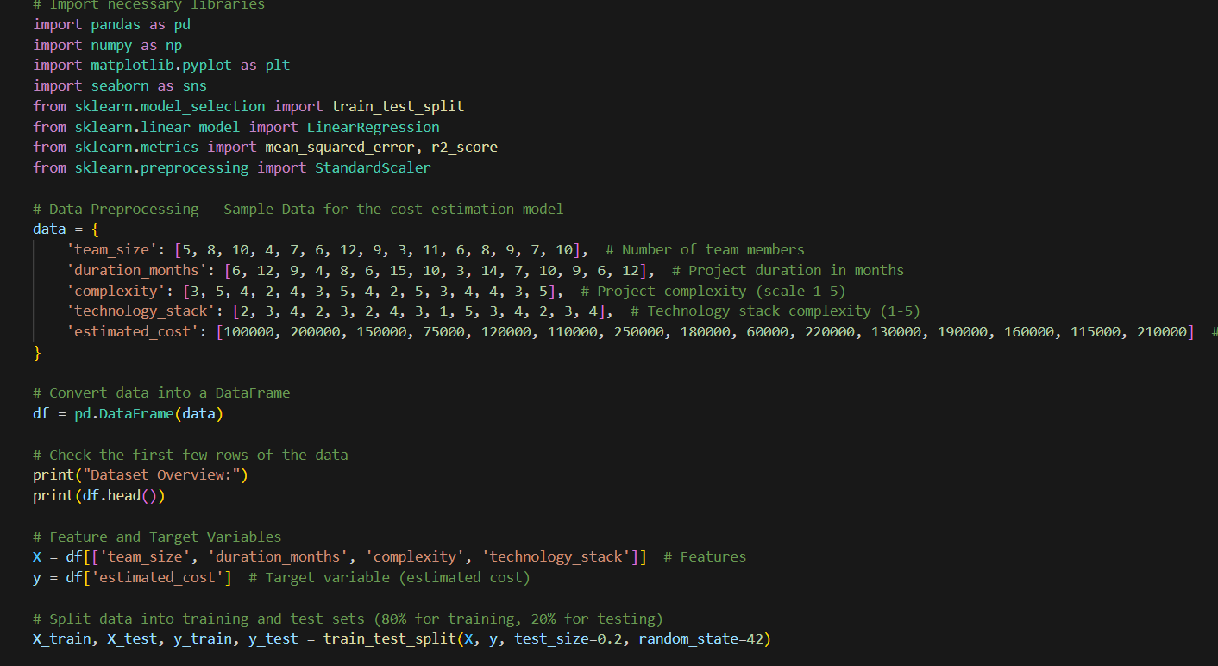

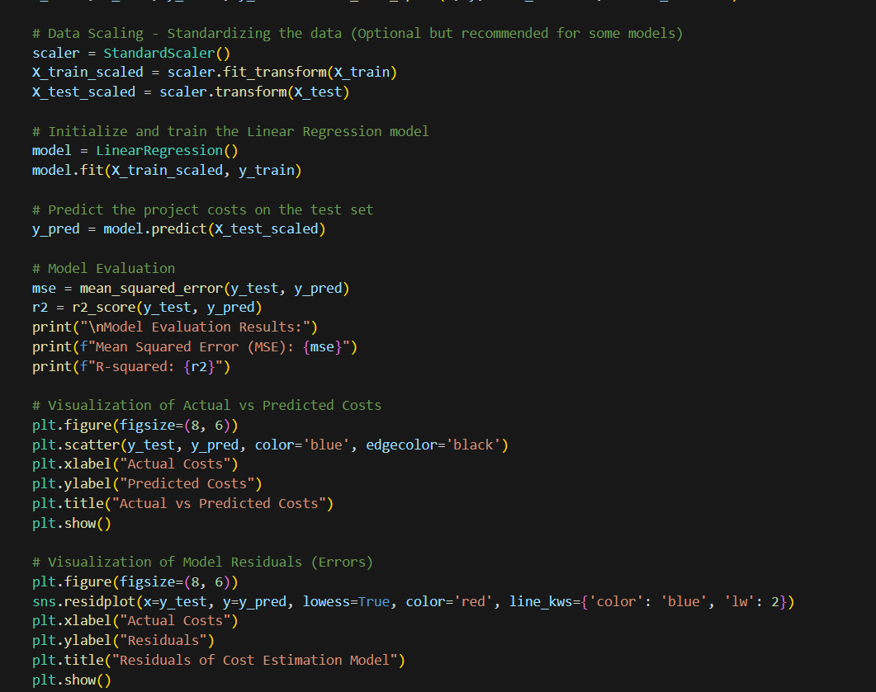

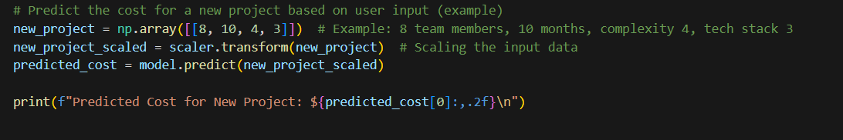

**OUTPUT:**

